Acceptance Conformity Report for Radar 5 SEL

Applicable for Radar 5 77 Gen1.2&Gen1.3 Product

RESTRICTED ACCESS

DISTRIBUTION :
Company Recipient Copies
CFM ShalocZhang 1
CFM Cecilia Xia 1
CFM Daniel Wang 1
CFM Steven Wu 1

REVISION

Revision Date Author Comments

A 2022-11-29 Shaloc Zhang Initial Release

CONTENTS

1. REFERENCE 4
2. OBjective 4
3. Method of measurement 5
4. List of the ACCEPTANCE CRITERIA for RDR04 SEL tester 5
5. Conclusion 5

REFERENCE

Trial date : 2022/11/25

Trial done by : Shaloc Zhang

Line : Radar 5

Fixture:
EPT-RDR05G1.2-03-01 | 77 G1.2 SEL夹具
EPT-RDR05G1.2-03-02 | 77 G1.2 SEL夹具
EPT-RDR05G1.3-02-01 | 77 G1.3 SEL夹具
EPT-RDR05G1.3-02-02 | 77 G1.3 SEL夹具

Product: Radar 77 Gen1.2&Gen1.3

Software: Labwindows CVI, Teststand

OBjective
Verify the conformity of the Rada05 SEL with the production requirements and validate it can be used for production.

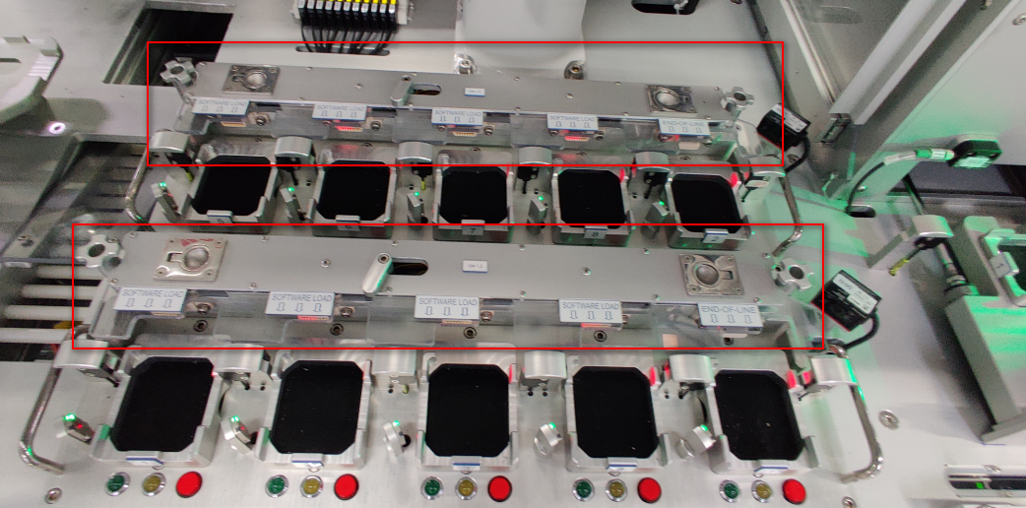

Method of measurement
The acceptance criteria has been defined and listed for the Radar 05 SEL and the Fixture will be verified to meet the acceptance criteria.

List of the ACCEPTANCE CRITERIA for SEL tester
See the attached file.
List of the Acceptance Criteria For Radar 5 SEL tester.

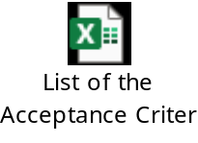

Conclusion
The Radar 5 SEL tester is conformed to meet the acceptance criteria and production requirements.

